Movement Problem Statement:

Movement:

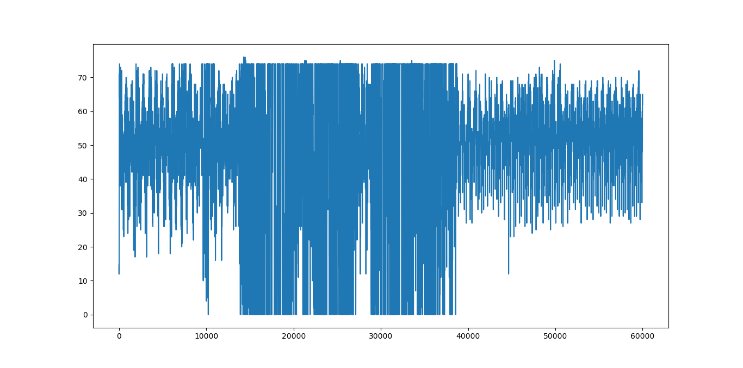

No Movement:

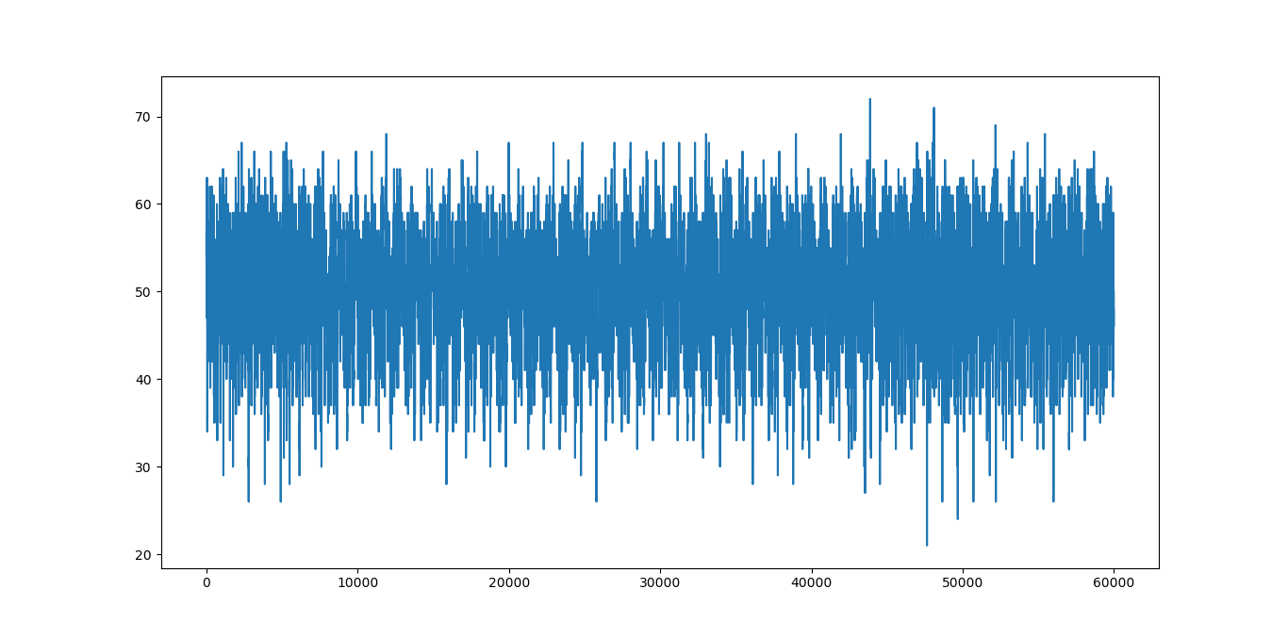

1. Initially data with movement and without movement was observed.(Data Collection)
2. Mean and standard deviation for data with movement and data without movement was extracted.(Feature extraction)

Without movement-Mean-50,Standard deviation-10.

With movement-Mean-50,Standard deviation-23(for reading above mean),50(for reading below mean)

1. Probability density of the testing data with movement parameters(mean,standard deviation)(Pwithmovement) and without movement parameters(mean,standard deviation)(Pwithoutmovement) was estimated.
2. If Pwithmovement>Pwithoutmovement,then the result is there is movement otherwise there is no movement.